**SOFTWARE REQUIREMENT SPECIFICATION**

**DOMAIN :- Online Football Shopping Cart**

Akash Varughese Joseph

20112002

4BSc DS

Anirudh Prashanth

20112004

4BSc DS

**INDEX**

**Table of Contents**

| 1. **Introduction** | **4** |
| --- | --- |
| **1.1 Purpose** | **4** |
| **1.2 Scope** | **4** |
| **1.3 Definition** | **4** |
| **1.4 Overview** | **4** |
| 1. **Overall Description** | **5** |
| **2.1 Product Perspective** | **5** |
| **2.2 Product Functions** | **5** |
| **2.3 Existing System** | **5** |
| **2.4 Product Functions** | **5** |
| **2.5 User Characteristics** | **6** |
| **2.5.1 User Requirements** | **6** |
| **2.5.2 User Education Level** | **6** |
| **2.5.3 User’s Technical Expertise** | **6** |
| **2.6 Principle Actors** | **6** |
| **2.7 Assumptions** | **6** |
| 1. **Specific Requirement** | **7** |
| **3.1 Functional Requirements** | **7** |
| **3.2 Description** | **7** |
| **3.3 Interface Requirement** | **7** |
| **3.4 Performance Requirements** | **7** |
| **3.5 Software Interface** | **8** |
| **3.6 Hardware Requirement** | **8** |
| 1. **Diagram** | **9** |
| **4.1 Entering to first 2 pages** | **9** |
| **4.2 Entering to shopping portal** | **10** |
| **4.3 Checkout process** | **11** |
| **4.4 Use Case Diagram** | **12** |

1. **INTRODUCTION**

**1.1 Purpose**

This document helps us to get familiar with the features of the application created which is a Football Cart Shopping (FCS) which is named as SportChek. This Online Store helps us to add our favorite items to the cart and can purchase it by viewing the total amount. This online shopping cart enables us to purchase our favorite items without having to visit the shop physically. It also has various shopping categories in which the customers will have a wide range of products to look at.

**1.2 Scope**

This platform helps us to view different products from various sports categories in which the customer can select their favorite items and can get the total amount.

**1.3 Definition**

FCS - Football Cart Shopping

SRS - Software Requirement Specification

GUI - Graphical User Interface

RAM - Random Access Memory

MB - Megabytes

GB - Gigabytes

HDD - Hard Disk Drive

**1.4 Overview**

This platform allows the user to select their favorite items and can view the total price and purchase it without even visiting physically to a shop. The coming sessions will give a brief idea on what exactly this application helps us to do.

1. **OVERALL DESCRIPTION**

**2.1 Problem Statement**

Building an online football shopping cart in which it allows the user to purchase their desired football accessories.

**2.2 Product Perspective**

This product is aimed at the category of people who don’t want to visit a shop physically to buy their desired football accessories for adding up to their kit.

**2.3 Existing System**

The application which we made as of now has many drawbacks, some of the following drawbacks are :

* We could just add the items to the cart and have the total amount of the purchase.
* FCS doesn’t have a selected items count for which we may not know how many items are selected in total.
* Once any item is selected we are not having any option to delete the unwanted item.

**2.4 Product Functions**

The users have the complete freedom to select wanted products, ask any queries based on related products.

**SELECTION**: This function is allowing the users to select their desired products in the given menu so that the items can be added to the cart.

Different places where selection function can be used are:

* Shop Menu

1. Jersey
2. Football Boots
3. Football Socks
4. Football Shin Guards
5. Footballs

**TOTAL**: This function is allowing the user to get the grand total of the items which were selected by the user.

This function is also assigned as a static variable so that it doesn’t have a fixed value as selecting items from different pages, it keeps on adding the total amount the user needed to pay.

**2.5 User Characteristics**

The user should be familiar with creating an account, adding items to the cart, and mainly ability to choose whatever he/she wants from the cart.

**2.5.1 User Requirements**

* User’s name, phone number address and other needed details.

**2.5.2 User Education Level**

* The user of the system should at least be comfortable with understanding the English language.

**2.5.3 User's Technical Expertise**

* Users should be comfortable using any basic application which runs on a computer.
* This application is built mainly focusing on the system effectiveness.

**2.6 Principle Actors**

There are 2 main principle actors in this application and they are the Customer and the administrator.

Customers can create an account while entering the home page of the application and also can ask queries related to any products in the application.

**2.7 Assumptions**

* Internet connectivity is not required for running the application.
* Browsers such as Firefox, Google Chrome aren't necessary for running this application.

1. **SPECIFIC REQUIREMENT**

**3.1 Functional Requirements**

This section provides you an overview of the system.

**3.2 Description**

* Create an Account
* Go to shopping page
* Shop menu with different options
* Adding items to the cart
* Calculating the total amount of the selected items.

**3.3 Interface Requirement**

1. Introduction Page

2. Create an account

3. Created Successfully

4. Go to Shopping page

5. Shop Menu Page

6. Jersey Page

7. Football Boots Page

8. Football Socks Page

9. Football Shin Guard Page

10. Football Page

11. Support Page

12. Checkout Page

13. Final Checkout successful page

**3.4 Performance Requirements**

* **User Satisfaction:** The design and the application is just built in a quality way that user satisfaction is maintained.
* **Response Time:** The response of all the operations present in the application is in a good way.
* **User Friendly:** The application is built in a way that it is easily accessible by beginners also for selecting their wanted items. Everyone can use this application in an effective mannes without any difficulties.

**3.5 Software Interface**

* Operated and designed with JavaFx and SceneBuilder.
* Any window based operating system with DOs are the primary requirement for software development.

**3.6 Hardware Requirements**

Hardware requirements play a crucial role in the smooth running of the application.

1. **Minimum Hardware Requirements**

* Processor Pentium IV
* 100GB HDD
* 1GB RAM

1. **Prefered Hardware Requirements**

* Processor Core i3
* 500GB RAM
* 4GB RAM

**4. DIAGRAMS**

**4.1 Entering new page to the first 2 pages**

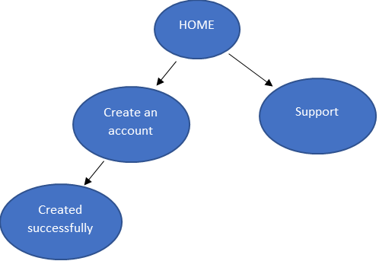

**4.2 Entering the Shopping portal**

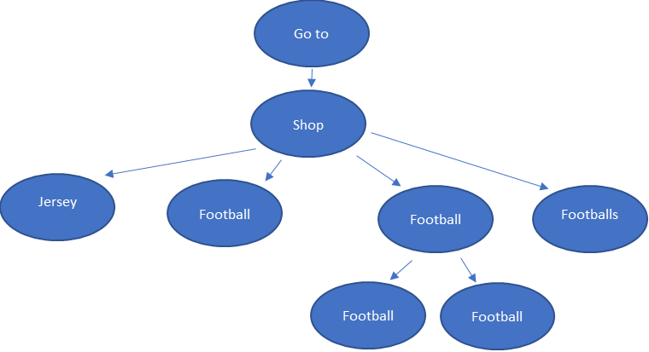

**4.3 Checkout process**

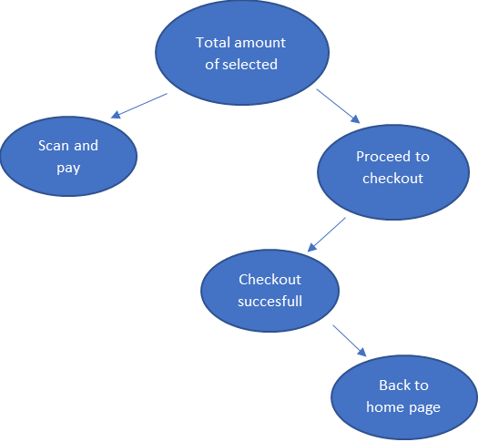

**4.4 Use Case Diagram**

